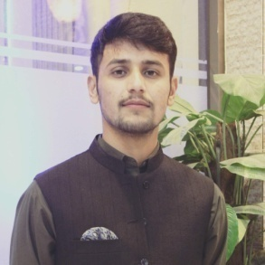**MUHAMMAD ABBAS**

**Address:** Peshawar KPK

**Phone:** +92 3489188854

**Email:** abbiezia717@gmail.com

(**MERN Stack)**

**Education:**

BS Computer Science from UET Peshawar (Sep 2019 - Aug 2023).

F.Sc from Jahanzeb College Swat (2016-2018).

Matric from QPS Charbagh Swat (2014-2016).

**Projects:**

1: Chat App where users can connect with all the users across the app and can talk to each other. Tech Used **React, Express, Mongodb, Sockets, REST API, styled-components.**

2: Hotel Renting Website. Tech Used **React, Express, Mongodb, REST API.**

3: Weather Forecast, Tech Used **React**, **OpenWeatherAPI, styled-components.**

**Experience:**

I have not worked anywhere before so I have no prior experience.

**Personal:**

Seasoned and independent Web Developer with 1 year of experience (Self-learning locally ) in blending the art of design with skill of programming to deliver an immersive and engaging user experience through efficient website development , and relentless debugging.

**Professional skills:**

Responsive UI Design JavaScript React

Node Js(Express) MongoDb Postman

**Languages:**

English (Fluent) Urdu (Fluent) Pashto (Native)

**Hobbies:**

Badminton Cricket Reading

**Interests:**

Web Development Blockchain